**EXPERIMENT NUMBER- 19**

**AIM**

* Write a Javascript Program to display absolute positioning.

**DESCRIPTION**

* Javascript is also used to make XHTML document dynamic after the document being displayed by browser.
* Content of elements are changed dynamically i.e changes can be made  
  after the document has been being displayed.
* A element can be placed at specific position in the document using  
  absolute value for the position styling property
* With absolute positioning elements are placed without regard to the  
  positions of other elements.

**PROGRAM(S)**

<!DOCTYPE html>

<html>

<head>

<style type="text/css">

.regtext{font-familly:Times;font-size:14pt;width:600px}

.abstext{position:absolute;top:50px;left:50px;font-familly:Times;font-

size:24pt;width:500px;color:red;}

</style>

</head>

<body>

<p class="regtext">

A element can be placed at specific position in the document using absolute

value for the position styling property. Absolute positioning defines the x and y

coordinates of an element with reference to the top left corner of the browser page or the

containing block and the position attribute is set to absolute. With absolute positioning

elements are placed without regard to the positions of other elements.

</p>

<p class="abstext">

this absolute POSITION

</p>

</body>

</html>

**RESULTS/OUTPUT**

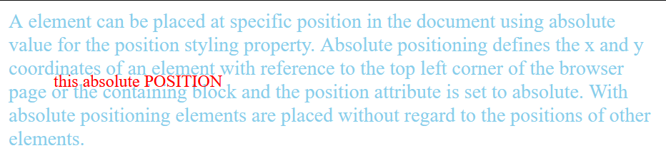

**CONCLUSION**

We are able to implement absolute positioning of elements.

**EXPERIMENT NUMBER- 20**

**AIM**

* Write a Javascript Program to display relative positioning.

**DESCRIPTION**

* Javascript is also used to make XHTML document dynamic after the document being displayed by browser.
* Content of elements are changed dynamically i.e changes can be made  
  after the document has been being displayed.
* The element is positioned relative to its normal position.

**PROGRAM(S)**

<!DOCTYPE html>

<html>

<body style="font-family:Times;font-size:20pt;">

<p>

CBIT CSE<span style="position:relative;top:-20px;left:30px;

font-family:Times;font-size:40pt;

font-style:italic;color:red;">

B.E-3/4,CSE-2</span>hyderabad

</p>

</body>

</html>

**RESULTS/OUTPUT**



**CONCLUSION**

We are able to relative positioning of elements.

**EXPERIMENT NUMBER- 21**

**AIM**

* Write a Javascript Program to move elements.

**DESCRIPTION**

* Javascript is also used to make XHTML document dynamic after the document being displayed by browser.
* Content of elements are changed dynamically i.e changes can be made  
  after the document has been being displayed.
* By changing the left and top values also move the element to a specified position.

**PROGRAM(S)**

<!DOCTYPE html>

<html>  
<head>  
<script type="text/javascript">

function moveIt(mov,newTop,newLeft)  
{  
var x=document.getElementById(mov).style;  
x.top=newTop+"px";  
x.left=newLeft+"px";  
}  
</script>  
<body>  
<form action="">  
<p>  
<label>  
x coordinate:  
<input type="text" id="left" size="3"/>  
</label>  
<br/>  
<label>  
y coordinate:  
<input type="text" id="top" size="3"/>  
</label>  
<br/>  
<input type="button" value="Move"  
onclick="moveIt('image',document.getElementById('top').value,document.getElementById('left').value)"/>  
</p>  
</form>  
<div id="image" style="position:absolute;top:100px;left:0px">  
<img src="smiley.gif" alt="not displayed" height="100" width="100"/>  
<p>cbit</p>  
</div>  
</body>  
</html>

**RESULTS/OUTPUT**

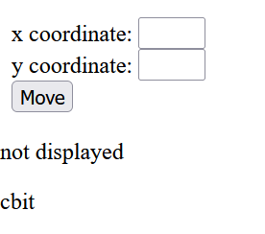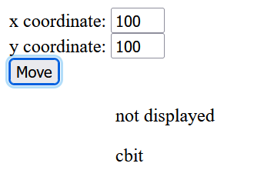

**CONCLUSION**

We are able to implement moving of elements.

**EXPERIMENT NUMBER- 22**

**AIM**

* Write a Javascript Program to display element visibility properties.

**DESCRIPTION**

* Javascript is also used to make XHTML document dynamic after the document being displayed by browser.
* Content of elements are changed dynamically i.e changes can be made  
  after the document has been being displayed.
* XHTML elements can be visible or hide by using the property visibility with values  
  visible and hidden

**PROGRAM(S)**

<!DOCTYPE html>

<html>

<body>

<p id="myP">This is a p element.</p>

<button type="button" onclick="myFunction()">Hide content of p</button>

<script>

function myFunction() {

document.getElementById("myP").style.visibility = "hidden";

}

</script>

</body>

</html>

**RESULTS/OUTPUT**

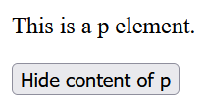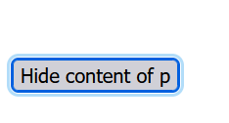

**CONCLUSION**

We are able to implement visibility properties of elements.

**EXPERIMENT NUMBER- 23**

**AIM**

* Write a Javascript Program to display stacking of elements.

**DESCRIPTION**

* Javascript is also used to make XHTML document dynamic after the document being displayed by browser.
* Content of elements are changed dynamically i.e changes can be made  
  after the document has been being displayed.
* The z-index attribute determines which element is in front and which are covered by the front element
* The JavaScript property associated with the z-index attribute is zIndex
* z-index can be changed dynamically

**PROGRAM(S)**

<!DOCTYPE html>

<!DOCTYPE html>

<html>

<head>

<style>

#img1 {

position: absolute; left: 0px; top: 0px;z-index: -1

}</style></head>

<body>

<h1>This is a Heading</h1>

<img id="img1" src="airplane1.jpg" width="500" height="500">

<button type="button" onclick="myFunction()">Change stack order</button>

<p>Default z-index is 0. Z-index -1 has lower priority.</p>

<script>

function myFunction() {

document.getElementById("img1").style.zIndex = "1";

}

</script>

</body>

</html>

**RESULTS/OUTPUT**

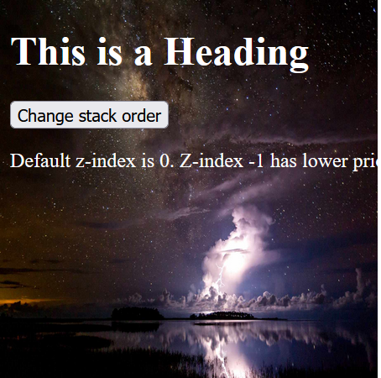 

**CONCLUSION:** We are able to implement stacking of elements.